Whois Domain Model

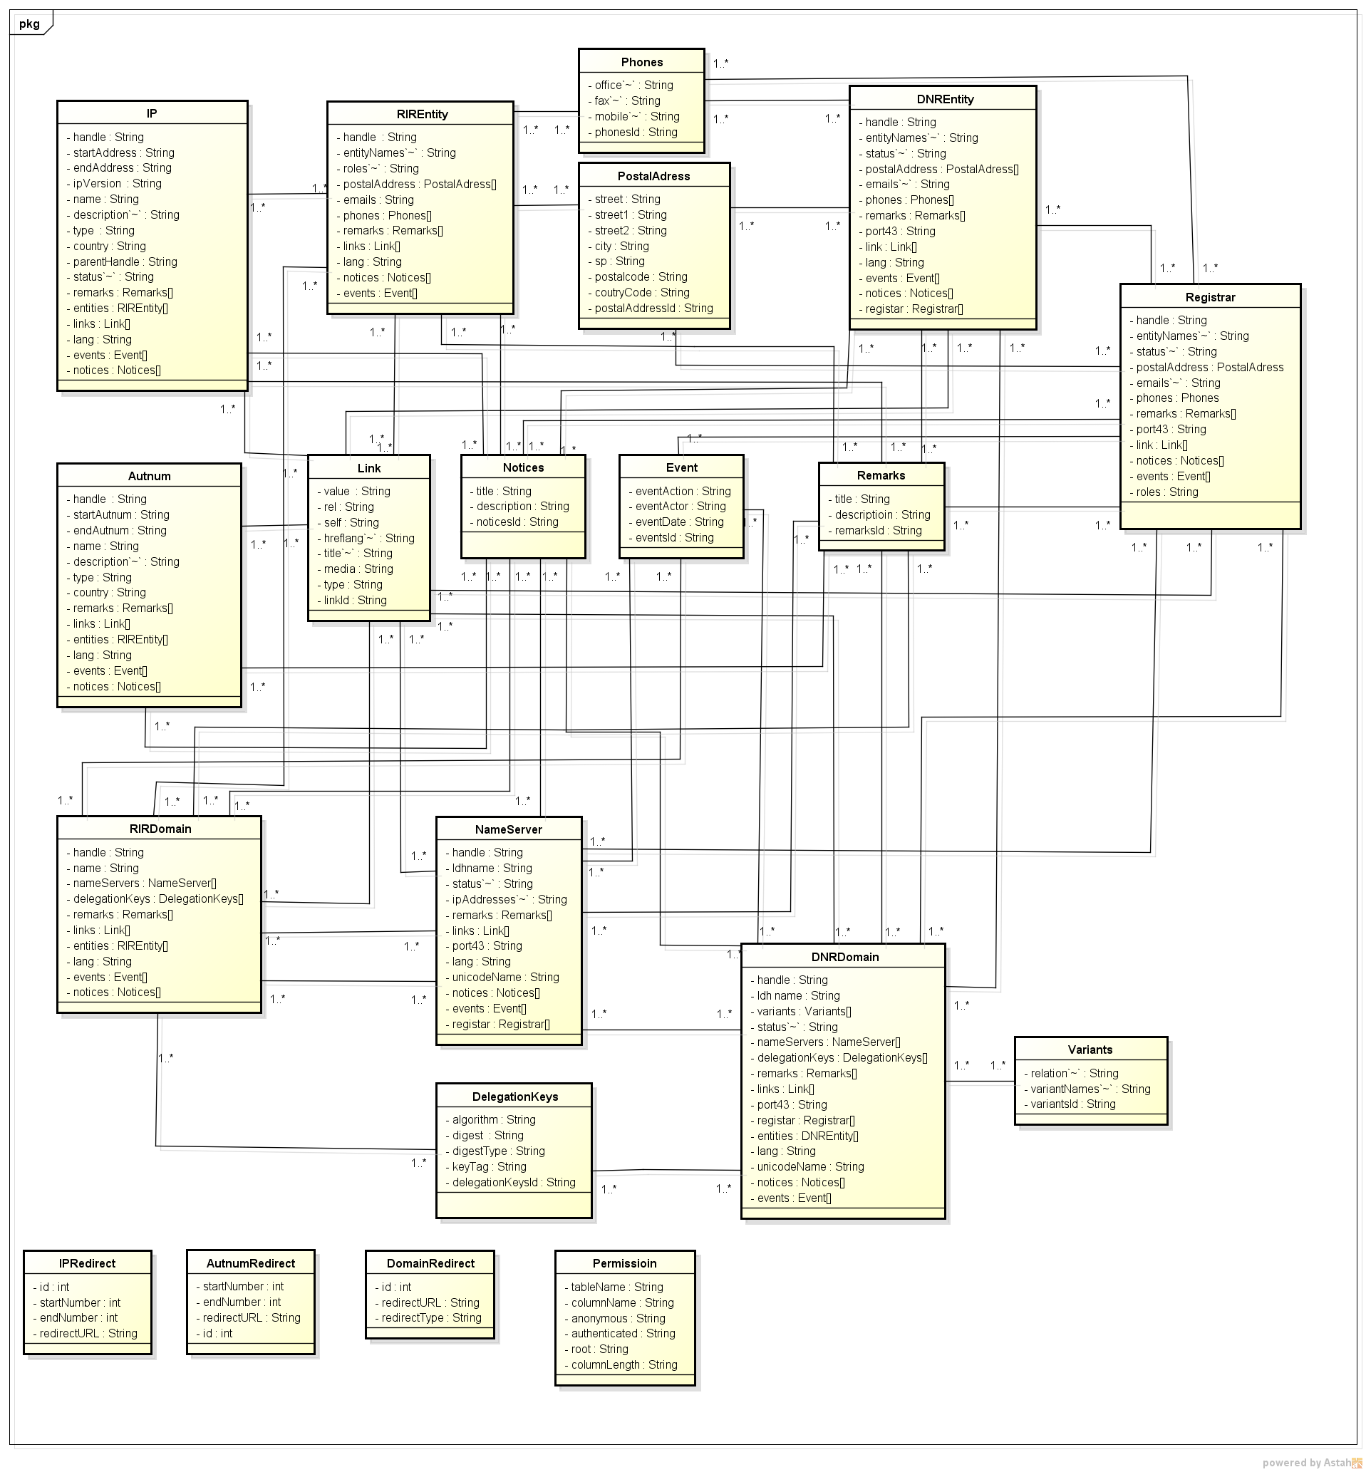

The figure depicts the tables and fields in the database，And reflect the correspondence between the table and the table。